Task 1: Create a comparison table listing at least 5 key differences between traditional WAN and SD-WAN, focusing on how data is routed, managed, and secured.
Feature | Traditional WAN | SD-WAN (Software-Defined WAN)
Branch Deployment & Provisioning | High Touch (Manual Configuration): Setting up a new branch office requires an experienced network engineer to physically visit the site, connect a console cable, and manually type configurations into the command line. | Zero-Touch Provisioning (ZTP): Non-technical staff can plug the hardware in at a new branch. The device automatically connects to the internet, phones home to the central controller, and downloads its entire configuration.
Data Routing Control | Hardware-Based / Decentralized: Routing decisions are made locally on each individual router using static rules or traditional routing protocols (like BGP, OSPF). It cannot dynamically shift traffic based on real-time internet performance. | Software-Based / Centralized: A centralized software controller dynamically directs traffic across the network based on real-time conditions (latency, jitter, packet loss) and application priority.
Management & Configuration | Device-by-Device Management: Network administrators must manually configure each router individually via a Command Line Interface (CLI). Modifying corporate-wide rules requires updating every node manually. | Centralized Orchestration: The entire network infrastructure is managed through a single centralized software dashboard. Changes to traffic or firewall rules are pushed out to all locations simultaneously.
Traffic Security Deployment | Perimeter / Add-On Security: Security must be handled by deploying and managing separate, dedicated firewall hardware at each remote branch office, or by backhauling all internet traffic to a central headquarters firewall. | Integrated / Native Security: Security features like end-to-end IPsec tunnel encryption, next-generation firewalls, and cloud security integrations (SASE) are natively built right into the software platform.
Circuit Underlay Flexibility | Rigid / Dedicated Lines: Relies primarily on expensive, private leased circuits like MPLS to guarantee connection quality. Adding secondary connections often requires matching hardware architectures. | Transport-Agnostic: Seamlessly blends and aggregates multiple different connection types simultaneously, including cheap broadband internet, 5G/4G cellular links, and private MPLS lines.
Application Performance Awareness | Packet-Blind: Treats all data packets identically based only on their destination IP address. It cannot differentiate between a mission-critical Zoom video call and a background file download without complex QoS configuration. | Application-Aware: Automatically identifies specific applications (e.g., Office 365, Salesforce) and prioritizes their traffic dynamically to ensure critical business apps always get the cleanest network path.
Cloud Integration Architecture | Inbound Hairpining: Traffic destined for cloud services (like AWS, Azure, or Office 365) must first be routed back to the main headquarters data center before heading out to the internet, creating severe performance bottlenecks. | Direct Cloud Access (DCA): Identifies cloud-bound traffic at the network edge and routes it directly to the closest cloud data center over local internet connections, bypassing headquarters to reduce latency.
Network Visibility & Analytics | Fragmented Diagnostics: Troubleshooting requires engineers to log into multiple individual boxes across different sites using terminal commands to manually piece together traffic flows and spot faults. | Unified Single-Pane Analytics: Provides deep, real-time visualization of the entire network fabric from a single screen, detailing exactly how much bandwidth applications are using and tracking circuit health history.

Task 2: Draw a simple network diagram (on paper or using a tool like draw.io) showing how SD-WAN connects multiple branch offices to cloud apps (like Office 365 or AWS) and the main data center. Label the SD-WAN controllers, edges, and at least two types of WAN links (e.g., MPLS, broadband).
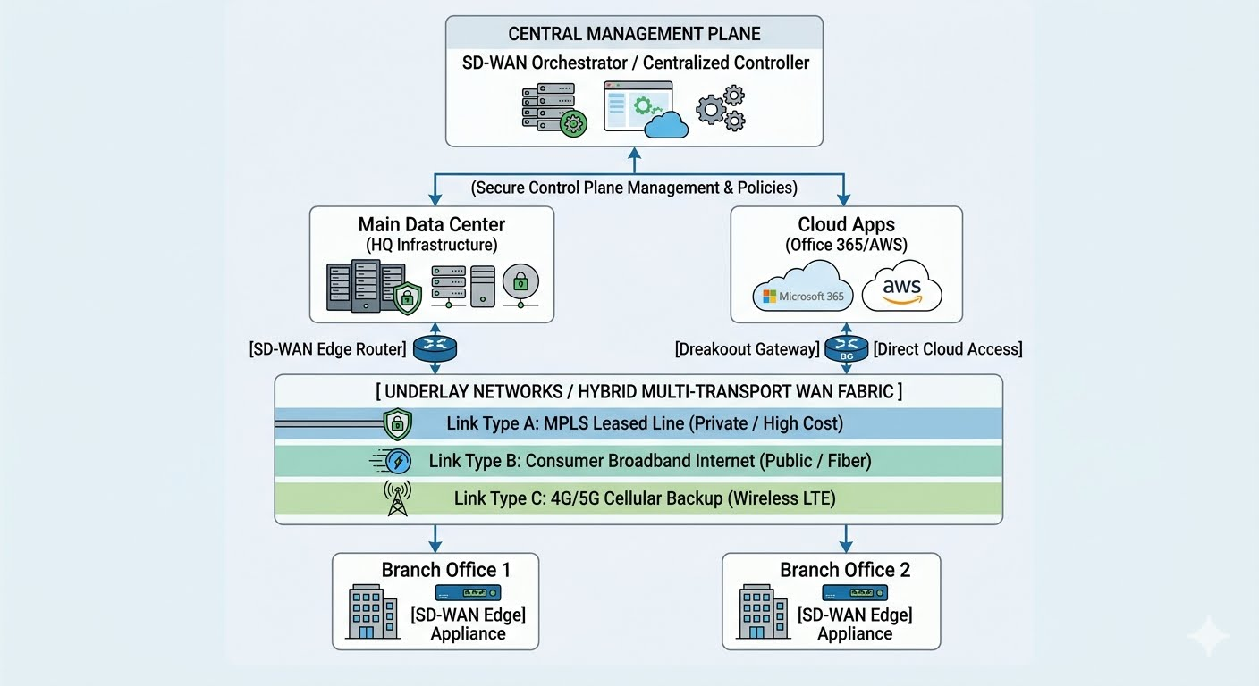

Architectural Plane Breakdown
Central Management Plane (The Orchestrator): Positioned at the absolute top of the topology, this software-driven layer handles the control policies and configurations. Network policies are created here once and seamlessly pushed out across secure control channels to all connected edge nodes.
The Hybrid Underlay Transport Fabric: Instead of binding your branch offices to a single rigid path, the data plane bonds multiple network connection flavors simultaneously:
- MPLS Leased Lines: Kept active for high-priority, secure data exchanges directly into the Main Data Center.
- Consumer Broadband / Fiber: Deployed to absorb heavy internet and SaaS application demands cheaply.
- 4G/5G Cellular Links: Maintained as an auto-switching backup transport layer to achieve maximum link availability.
Direct Cloud Access (DCA): The branch office edge appliances are engineered with application-aware routing. When traffic bound for public cloud platforms like AWS or Office 365 is identified, the appliance routes it straight to the internet locally, completely bypassing and offloading the main headquarters data center to optimize user performance.
1. Central Management Plane (The Network Brain)
The top tier of the diagram represents the separation of the control plane from the physical hardware. In traditional networking, every router acts as an independent entity, requiring individual configurations. SD-WAN introduces centralized orchestrators (like Cisco vManage or VMware VeloCloud Orchestrator) that function as a single point of control.
- Policy Orchestration: Administrators define business, routing, and security rules on a single dashboard. For example, a rule stating "Give Zoom calls maximum priority and drop them to LTE if broadband drops" is written once.
- Automated Distribution: The central controller packages this policy and pushes it down securely to all SD-WAN Edge appliances simultaneously across the country, ensuring uniform network behavior within seconds.
2. SD-WAN Edge Appliances (The Intelligent Gatekeepers)
- Application Recognition (Deep Packet Inspection): These devices inspect data at Layer 7 (the application layer). They instantly differentiate between a business-critical Salesforce query, an Office 365 upload, and an employee streaming background music.
- Dynamic Path Selection: The edge hardware continuously probes the active WAN links, checking for real-time performance metrics like latency, packet loss, and jitter. If Link Type B (Broadband) experiences a sudden brownout or quality drop, the edge appliance shifts voice and video packets to Link Type A (MPLS) in real-time, preventing dropped calls without user intervention.
3. The Hybrid Multi-Transport Fabric (The Underlay)
- Link Aggregation (Active-Active Paths): Instead of keeping backup lines idle until a main link fails, SD-WAN combines all available transports—MPLS, Broadband Fiber, and 4G/5G Cellular—into a single pool of bandwidth. All links carry traffic simultaneously based on policy requirements.
- Cost Optimization: High-cost MPLS lines can be reserved strictly for sensitive internal financial or database traffic heading to the Main Data Center. Massive, non-critical web traffic can be offloaded onto cheap, high-speed consumer broadband lines, drastically reducing monthly telecom bills.

4. Direct Cloud Access & Breakout (Optimizing SaaS App Performance)
- Local Internet Breakout: The SD-WAN Edge appliance identifies cloud-destined packets right at the branch boundary. If a user in Branch Office 1 opens an Office 365 document, the appliance splits that traffic away from the enterprise MPLS network and routes it directly out to the local public internet connection.
- Reduced Latency: By establishing a direct path to the closest cloud data center, app performance speeds up dramatically, and the core corporate data center is saved from processing irrelevant web traffic.
Task 3: Pick any app you use daily (like WhatsApp, Zomato, or Instagram) and write a short scenario explaining how SD-WAN could improve user experience for that app when used across multiple cities in India. Think about speed, reliability, and security when users access the app from different locations.
1. Blazing Speed via Direct Cloud Access (DCA)
The Challenge: When a user in Chennai opens Zomato, their request goes to Zomato's application backend hosted on cloud platforms like AWS. In an old networking system, regional offices or local hub nodes would have to send that traffic back to a main Mumbai data center first before it could go out to the cloud, causing frustrating screen-loading delays.
The SD-WAN Improvement: SD-WAN appliances at regional Indian hubs recognize cloud-bound traffic instantly via application-aware routing. It breaks this traffic out to the local public internet immediately, sending the user's order straight to the nearest cloud data center. This slashes app latency, ensuring that menus load instantly and payments clear in seconds.
2. Unmatched Reliability with Dynamic Multi-Pathing
The Challenge: During peak monsoon seasons or infrastructure upgrades in major Indian hubs, physical underground fiber lines frequently suffer accidental cuts or severe line noise, causing internet "brownouts" or total dropouts.
The SD-WAN Improvement: Zomato’s regional offices and fulfillment centers can use a hybrid blend of network paths simultaneously, such as high-speed broadband fiber, a private line, and a 5G cellular link. If the primary broadband connection in Kolkata suddenly drops or suffers severe packet loss, the SD-WAN edge appliance instantly shifts live order tracking and delivery dispatch data onto the 5G wireless link in under a second. The customer tracking their food delivery never experiences a frozen screen or a disconnected order.

3. Integrated Edge Security (Protecting Payment Data)
The Challenge: Zomato handles highly sensitive user data, including saved credit cards, UPI profiles, and exact residential addresses. Sending this sensitive information across hundreds of different local internet service providers across India creates a massive target for cybercriminals trying to intercept data.
The SD-WAN Improvement: SD-WAN automatically builds an end-to-end encrypted network overlay (IPsec VPN tunnels) across the entire country. No matter if a transaction is initiated from a small restaurant in Jaipur or a major corporate office in Gurugram, the data is scrambled before it even touches the public internet underlay. Furthermore, it integrates cloud-delivered firewalls (SASE) directly at the edge, ensuring malicious traffic or hacking attempts are blocked locally before they can ever reach Zomato’s core systems.
Task: 4 List and explain three key benefits of SD-WAN for a company with offices in Ahmedabad, Mumbai, and Bangalore. For each benefit, give a real-world example of how it would help employees or customers.
To keep this massive, time-sensitive system running without a single stutter, Zomato's underlying corporate and regional logistics infrastructure can rely on SD-WAN to optimize speed, reliability, and security.
1. Blazing Speed via Direct Cloud Access (DCA)
The Challenge: When a user in Chennai opens Zomato, their request goes to Zomato's application backend hosted on cloud platforms like AWS. In an old networking system, regional offices or local hub nodes would have to send that traffic back to a main Mumbai data center first before it could go out to the cloud, causing frustrating screen-loading delays.
The SD-WAN Improvement: SD-WAN appliances at regional Indian hubs recognize cloud-bound traffic instantly via application-aware routing. It breaks this traffic out to the local public internet immediately, sending the user's order straight to the nearest cloud data center. This slashes app latency, ensuring that menus load instantly and payments clear in seconds.
2. Unmatched Reliability with Dynamic Multi-Pathing
The Challenge: During peak monsoon seasons or infrastructure upgrades in major Indian hubs, physical underground fiber lines frequently suffer accidental cuts or severe line noise, causing internet "brownouts" or total dropouts.

The SD-WAN Improvement: Zomato’s regional offices and fulfillment centers can use a hybrid blend of network paths simultaneously, such as high-speed broadband fiber, a private line, and a 5G cellular link. If the primary broadband connection in Kolkata suddenly drops or suffers severe packet loss, the SD-WAN edge appliance instantly shifts live order tracking and delivery dispatch data onto the 5G wireless link in under a second. The customer tracking their food delivery never experiences a frozen screen or a disconnected order.
3. Integrated Edge Security (Protecting Payment Data)
The Challenge: Zomato handles highly sensitive user data, including saved credit cards, UPI profiles, and exact residential addresses. Sending this sensitive information across hundreds of different local internet service providers across India creates a massive target for cybercriminals trying to intercept data.
The SD-WAN Improvement: SD-WAN automatically builds an end-to-end encrypted network overlay (IPsec VPN tunnels) across the entire country. No matter if a transaction is initiated from a small restaurant in Jaipur or a major corporate office in Gurugram, the data is scrambled before it even touches the public internet underlay. Furthermore, it integrates cloud-delivered firewalls (SASE) directly at the edge, ensuring malicious traffic or hacking attempts are blocked locally before they can ever reach Zomato’s core systems.

